Long Row
Primary School
Calculations
Policy


February 2023
Year 1 – Addition & Subtraction

Objectives:
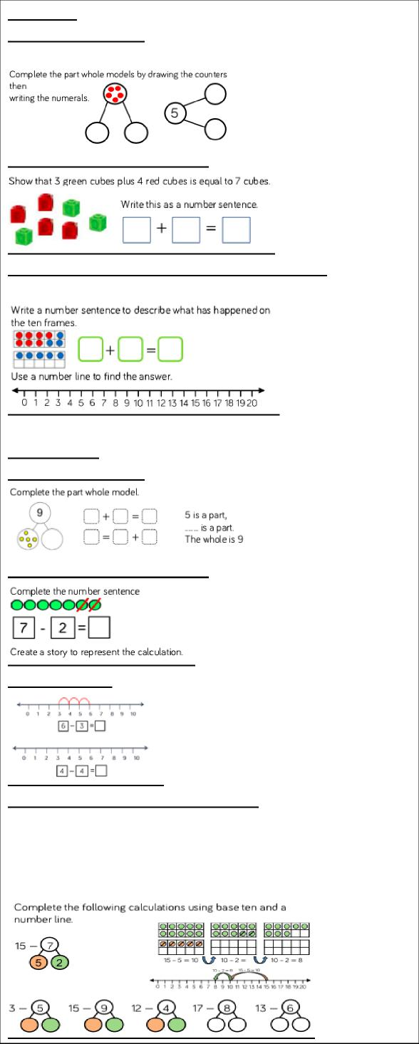
Addition:
Part whole model:
Combining 2 parts to make a whole using counters
Writing number sentences:
Writing number sentences:
Use number lines (first within 10 ,then 20):
Number lines:
- Read, write and interpret mathematical statements involving addition (+), subtraction (−) and equals (=) signs
- Represent and use number bonds and related subtraction facts within 20
- Add and subtract one-digit and two-digit numbers to 20, including 0
- Solve one-step problems that involve addition and subtraction, using concrete objects and pictorial representations, and missing number problems such as 7 = ? − 9
Progression: Children should have many opportunities to develop their understanding of addition and subtraction. By the end of Year 1, children should be able to use and recall facts up to 20.

Addition:
- Partitioning into 2 or more parts
Subtraction:
Part whole model:
- Using + and = symbols to write number sentences
- Addition fact families and commutativity
- Number bonds within 10
- = sign in different places
Key language:
Finding the difference:

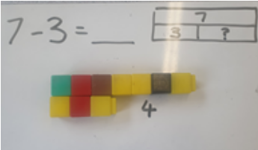
Equals, add, altogether, total, how many
more, plus, and, the same as, double, most,
count on, part, whole, more.
Subtraction:
- Concept of taking away practically and use of language
- Using – and = symbols
- Subtraction stories
- Fact families
- Counting back using number lines
Writing calculations (Crossing 10):
Children subtract numbers, within 20, crossing 10. They look at subtraction as take away. Then children look at subtraction as partitioning and then they will go on to see subtraction as the difference.
- Finding the difference (Visually or counting back)
Key language:
Equal to, take away, less, minus, subtract, leaves, difference, how many more/fewer, count back, least, how much less/more is... Bar model should be explored for both addition and subtraction.
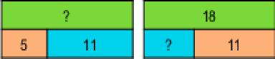

Year 2 – Addition & Subtraction

Objectives:

Addition: (Numbers up to 100)
Part whole model/bar model:
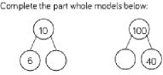
100
? 40
Add 2-digit and 1-digit (initially not crossing ten then move to crossing ten):
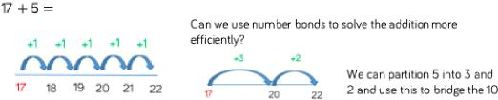
Add 2-digit and 2-digit
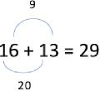
- Solve problems with addition and subtraction: -using concrete objects and pictorial representations, including those involving numbers, quantities and measures
-applying their increasing knowledge of mental and written methods
- Recall and use addition and subtraction facts to 20 fluently, and derive and use related facts up to 100
- Add and subtract numbers using concrete
objects, pictorial representations, and
mentally, including:
-a two-digit number and 1s
-a two-digit number and 10s
-2 two-digit numbers
-adding 3 one-digit numbers
- Show that addition of 2 numbers can be done in any order (commutative) and subtraction of 1 number from another cannot

- Recognise and use the inverse relationship between addition and subtraction and use this to check calculations and solve missing number problems

Subtraction:
If numbers are close together, count on:
82-79 79 + 1 + 1 +1 = 82

22-4
Progression:
Addition:
- Fact families
Subtract with 2-digits (initially not crossing tens then move to crossing ten)

- Related facts (If I know 2 + 3 = 5, then I know 20 + 30 = 50)
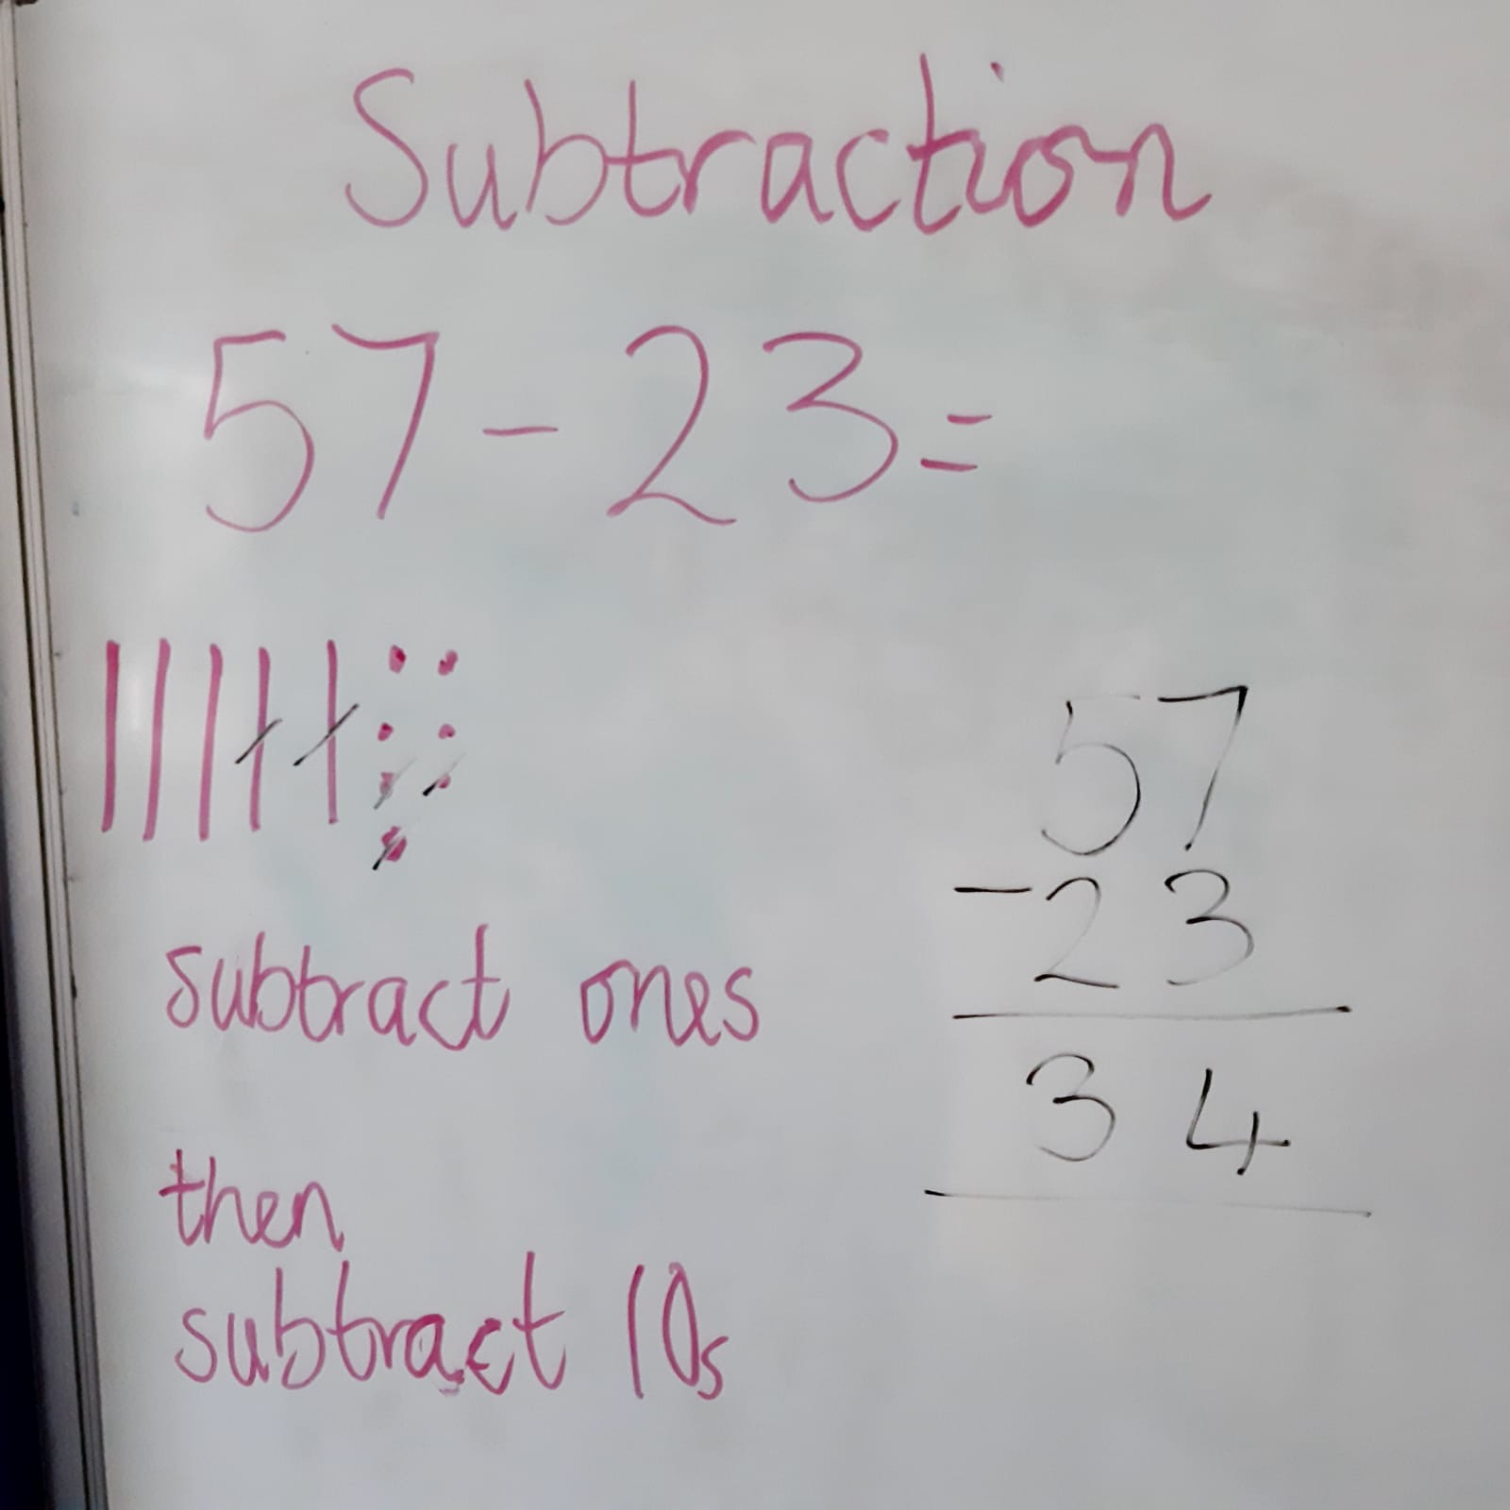

- Bridging through 10 (26 + 7 = 26 + 4 + 3)
- Number bonds to 100 (tens)
- Counting on/back in 10s (26 + 20 =)
- Add 2-digit and 2-digit
- Bonds to 100 (tens and ones)
- Add three 1-digit numbers
Key language:
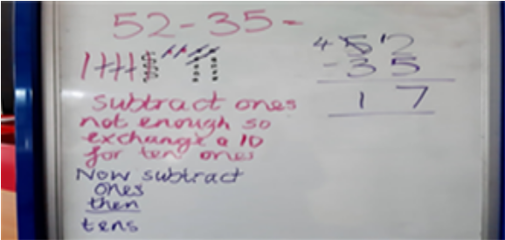
Add, more, plus, and, make, altogether, total,
equal to, equals, the same as, sum, tens, units,
partition, addition.
Subtraction:
- Fact families
- Subtract 1s
- 10 less
- Subtract 1-digit from 2-digit
- Subtract 2-digit from 2-digit (not crossing ten)
- Subtract 2-digit from 2-digit (crossing ten)
Childen should develop confidence at using the inverse operation to calculate subtractions

Year 3 – Addition & Subtraction
Written methods:
contined

Objectives:

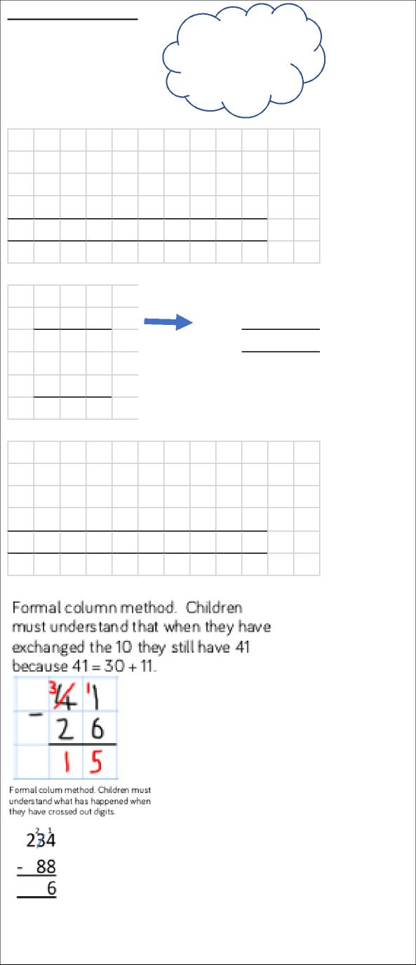
5
3
2
0
0
1
2 | 3 | 5 |  | + |  | 7 | 3 | = | 3 | 0 | 8
2 | 0 | 0 |  | + |  | 3 | 0 | + | 5
 |  |  |  |  |  | 7 | 0 | + | 3
2 0 0 + 1 0 0 + 8

 | 2 | 3 | 5
+ |  | 7 | 3
 | 2 | 0 | 8
 | 1

1 | 8 | 7 |  | - |  | 6 | 4 | =
1 | 8 | 7 |  | - |  | 6 | 0 | = | 1 | 2 | 7
1 | 2 | 7 |  | - |  | 4 | = | 1 | 2 | 3

Estimate
Calculate
Check
7
3
8
2
3
0
0
0
8
+
- Add and subtract numbers mentally, including:
- a three-digit number and 1s
- a three-digit number and 10s
- a three-digit number and 100s
- Add and subtract numbers with up to 3 digits, using formal written methods of columnar addition and subtraction
- Estimate the answer to a calculation and use inverse operations to check answers
Mental Methods:
Bridging to 10 (also with numberlines):
355 + 8 = 355 + 5 + 3
= 360 + 3
= 363
Adjusting:
326 + 90 = 326 + 100
= 426 – 10
= 416
246 – 9 = 246 – 10 + 1
= 236 + 1
= 237
246 – 50 = 246 – 40 – 10
= 206 – 10
= 196
Counting forwards or backwards in 100s:
648 + 200 = 848 648 – 500 = 148
Written methods:

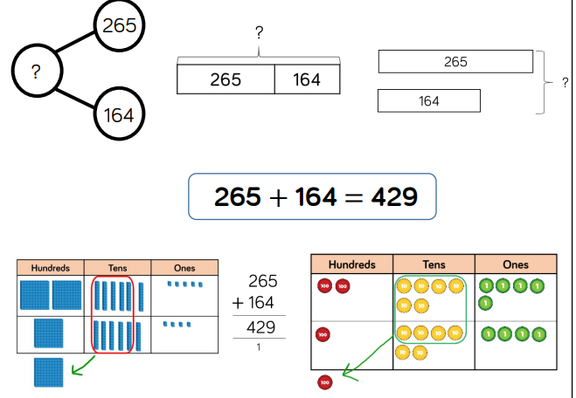
- Counting in 1s/10s
- Bridging through multiples of 10
- Partitioning
- Rounding and adjusting
- Reordering
- Near doubles
- Bridging through 60 (time)

Written methods: 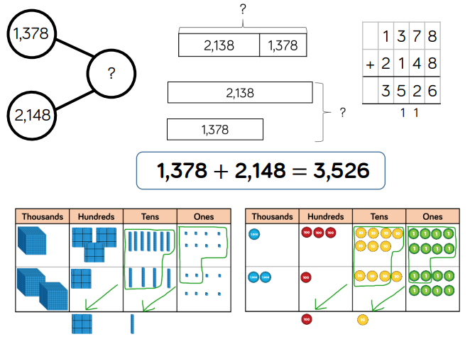
Written methods:
continued.

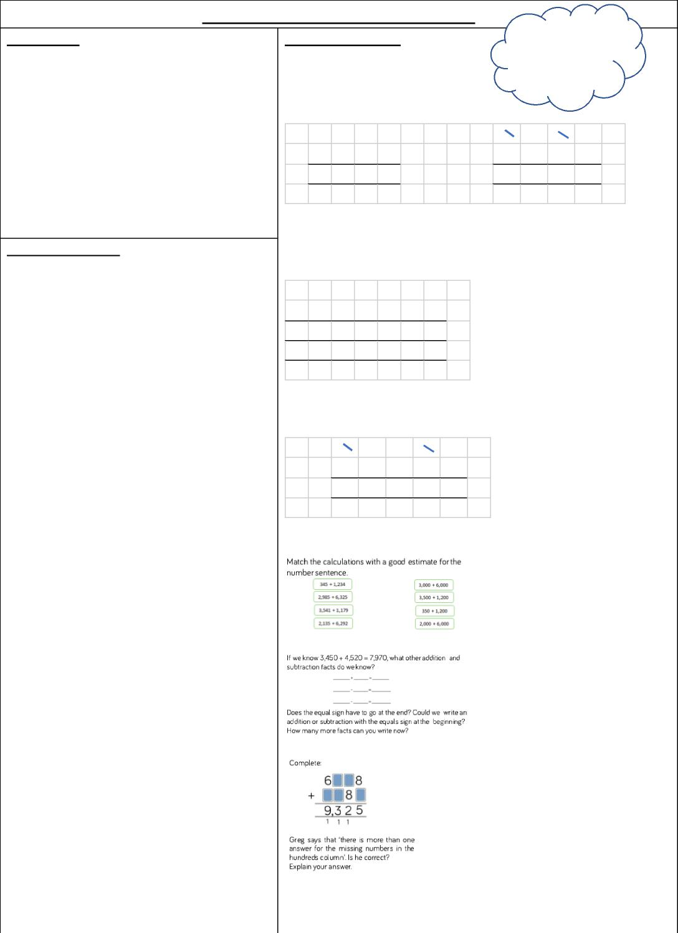
Year 4 – Addition & Subtraction
Objectives:
- Add and subtract numbers with up to 4 digits using the formal written methods of columnar addition and subtraction where appropriate
- Estimate and use inverse operations to check answers to a calculation
- Solve money problems to 2 decimal places
Estimate
Calculate
Check
 | 2 | 7 | 6 | 5 |  |  |  |  | 3₄ | 1₃ | 7₈ | 1₂
+ | 3 | 3 | 8 | 8 |  |  |  | - | 1 | 6 | 5 | 7
+ | 6 1 5 3 |  |  |  |  |  |  | 2 7 2 5
+ | 1 | 1 | 1

Mental Methods:
Develop confidence using full range of
strategies
(Money):
£32.50 + £21.75
£
•
2
3
0
5
+
•
1
2
£
7
5
•
£
2
5
5
4
1
£42.50 - £13.35
 | £ | 3₄ | 12 | • | 4₅ | 1₀
- | £ | 1 | 3 | • | 3 | 5
 | £ | 2 9 • 1 5

Estimate: Use skills of rounding to make sensible estimates.
Checking: Pupils learn to use inverse to check answers.
Missing number examples (White Rose):

789 + 642 becomes:
Check:
Is your answer close to your
estimate?

Efficient working e.g. £20 - £13.76 = column method of £19.99 - £13.75

- Estimate: rounding e.g. 800 + 640 = approx. 1440
Written methods:
Continue to use part whole model/bar mode.

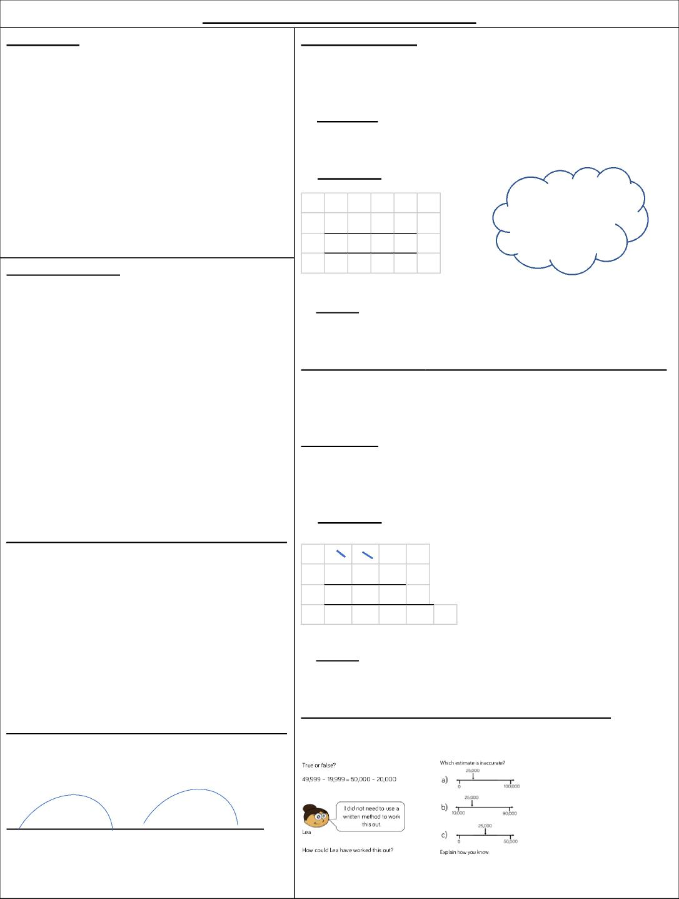
-
7
5
5
7
4
4
Year 5 – Addition & Subtraction
Objectives:
- Add and subtract whole numbers with more than 4 digits, including using formal written methods (columnar addition and subtraction)
- Add and subtract numbers mentally with increasingly large numbers
- Use rounding to check answers to calculations and determine, in the context of a problem, levels of accuracy
Mental Methods:
13 463 – 2300
Use knowledge of place value to calculate mentally with increasingly larger numbers.
Strategies to develop confidence:
2463 + 1999 =
2463 + 2000 = 4463
4463 – 1 = 4462
15 383 + 3 400 =
15 000 + 3 000 = 18 000
383 + 400 = 783
18 000 + 783 = 18 783
2001 – 1997
+ 3 + 1
1997 2000 2001
- Calculate:
 |  | 7 | 8 | 9
+ |  | 6 | 4 | 2
 | 1 4 3 1
 |  | 1 | 1

Estimate
Calculate
Check
- Check:
Is your answer close to your estimate?
932 – 457 becomes:
- Estimate: 900 – 500 = 400
- Calculate:
8₉
2₃
1₂
Estimate & Approximate examples:

Year 6 – Addition & Subtraction

Objectives:

Written methods:
Continue to use part whole model/bar model.

12 462 + 8456 becomes:
- Estimate:
12 500 + 8 000 = 20 500
- Calculate:
 | 1 | 2 | 4 | 6 | 2
+ |  | 8 | 4 | 5 | 6
 | 2 0 9 1 8
 | 1 1


Estimate
Calculate
Check
c) Check:
Is your answer close to your estimate?
13 601 - 5787 becomes:
a) Estimate:
14 000 – 6 000 = 8 000
b) Calculate:

 | 0₁ | 2₃ | 5₆ | 91₀ | 1₁
- |  | 5 | 7 | 8 | 7
 | 7 8 1 4

c) Check:
Is your answer close to your estimate?
Add / Subtract numbers with up to 3 decimal places: 13.6 – 2.78 = line up decimal points-

 | 1 | 23 | • | 15₆ | 1₀
- |  | 2 | • | 7 | 8
 | 1 0 • 8 2

- Perform mental calculations, including with mixed operations and large numbers
- Use their knowledge of the order of operations to carry out calculations involving the 4 operations
- Solve addition and subtraction multi-step problems in contexts, deciding which operations and methods to use and why
- Solve problems involving addition, subtraction, multiplication and division
- Use estimation to check answers to calculations and determine, in the context of a problem, an appropriate degree of accuracy
Mental Methods:

Pupils use a wide range of mental strategies including decimals and larger numbers.
What is 4 minus 0.007?
What is the sum of 5.3 and 12.6?

57 |  | = 125
57 | + | = 125
911 | - 47
911 | - 47 | =
149 | + 137 | + 158 | =
( ___ + | ___ ) - | ___ = 10
63 + ___ = 100 - ___

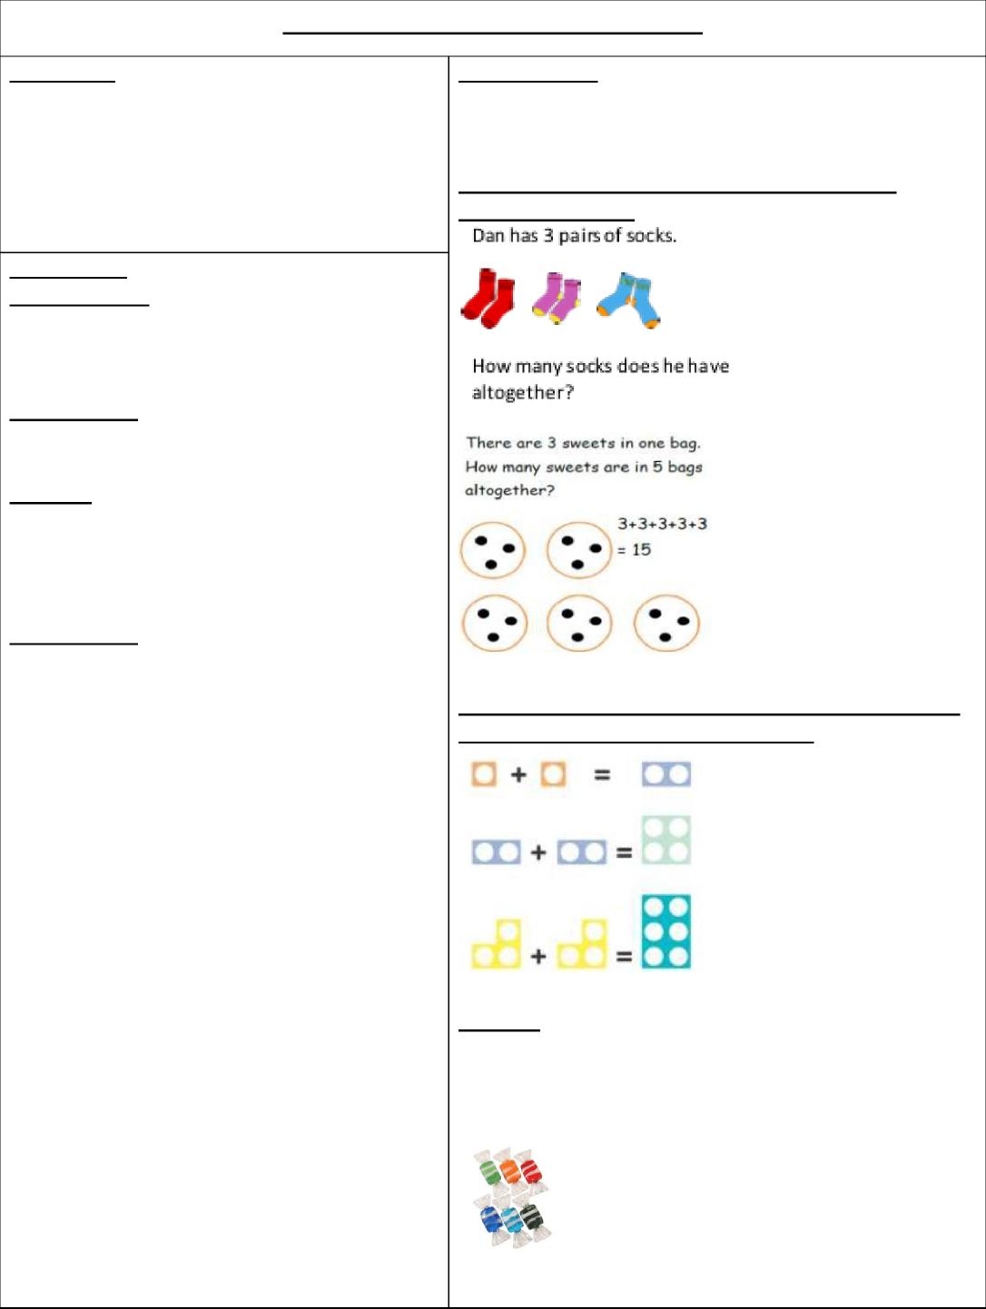
Year 1 – Multiplication & Division
Objectives:
- Solve one-step problems involving multiplication and division, by calculating the answer using concrete objects, pictorial representations and arrays with the support of the teacher
Use visual and concrete arrays and ‘lots of’ objects to find to ‘3 lots of 4’ etc (Use Numicon)
Division:
Concrete sharing activities:
Sam has 6 sweets and shares them equally between his
3 friends. How many sweets do his friends get?
Multiplication:
Count in multiples of 2s, 5s, 10s
Doubles up to 10
Practically making groups of objects leading to repeated addition:
Progression:
Multiplication:
- Concrete grouping of objects
- Pictorial grouping
- Repeated addition
Key language:
Groups, lots of, arrays
Division:
- Concrete sharing activities
- Pictorial sharing – drawing amounts in
sets
Key language:
Share, share equally, groups, lots of

Year 2 – Multiplication & Division

Objectives:
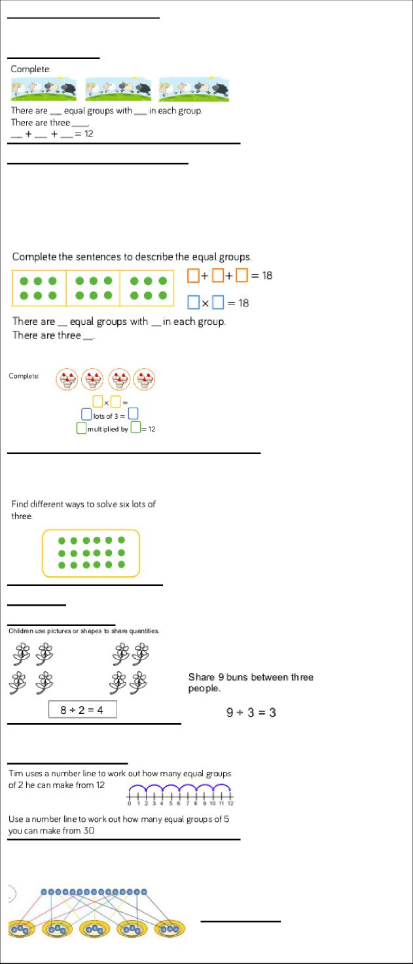
The multiplication symbol:
The multiplication symbol is introduced for the first time. Children should link repeated addition and multiplication together. The use of concrete and pictorial representations is still vital.
Children should know:
2 x table, 5 x table, 10 x table, Doubles up to 20 Equal groups:
Simple arrays to show commutativity 6 x 3
3 x 6
Division:
Sharing objects:
Grouping objects:
15 ÷ 3 = 5
(Extension: Count in 3s until you get to 15)
- Recall and use multiplication and division facts for the 2, 5 and 10 multiplication tables, including recognising odd and even numbers
- Calculate mathematical statements for multiplication and division within the multiplication tables and write them using the multiplication (×), division (÷) and equals (=) signs
- Show that multiplication of 2 numbers can be done in any order (commutative) and division of 1 number by another cannot
- Solve problems involving multiplication and division, using materials, arrays, repeated addition, mental methods, and multiplication and division facts, including problems in contexts
Progression:
Multiplication:
- Recognise, make and add equal groups
- Multiplication sentences using the x symbol
- Use arrays
- 2 times table
- 5 times table
- 10 times table
Division:
- Make equal groups – sharing
- Make equal groups – grouping
- Divide by 2
- Odd & even numbers
- Divide by 5
- Divide by 10

Year 3 – Multiplication & Division

x

Objectives:
Written methods: continued

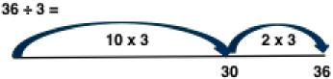

Short multiplication and division rely on mental methods at this stage. Children should be given short multiplication and division involving 2,3,4,5,6 and 10 times tables.
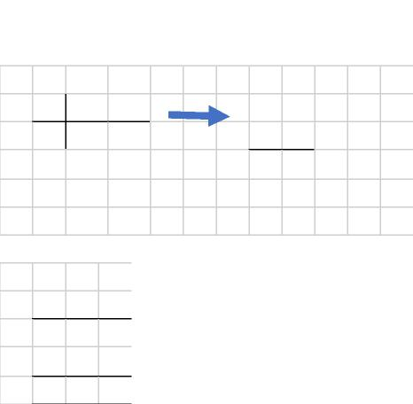

- Recall and use multiplication and division facts for the 3, 4 and 8 multiplication tables
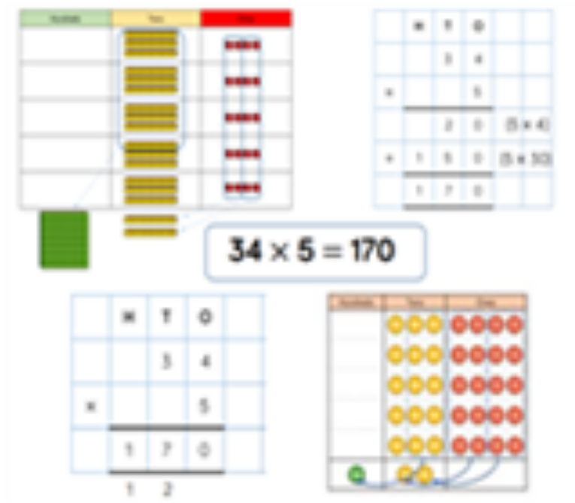
- Write and calculate mathematical statements for multiplication and division using the multiplication tables that they know, including for two-digit numbers times one-digit numbers, using mental and progressing to formal written methods
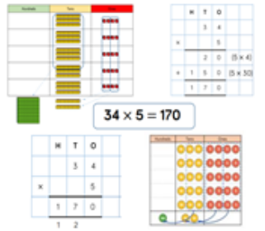
Mental Methods:
Children should now know 2x, 5x, 10x facts
They need to know:

- 4 x table
- 3 x table
- 8 x table
Division:
36 ÷ 3 = 12
And corresponding division facts.
Know fact families e.g.
4 x 3
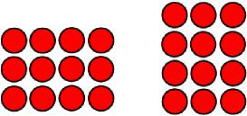
4 x 3 = 3 x 4
12 ÷ 3 = 4
12 ÷ 4 = 3

Written methods:
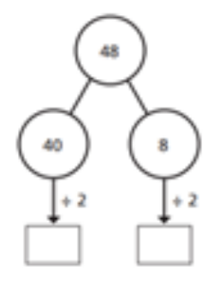
Part whole model/bar model e.g

Year 4 – Multiplication & Division

Objectives:

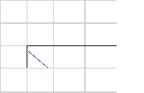

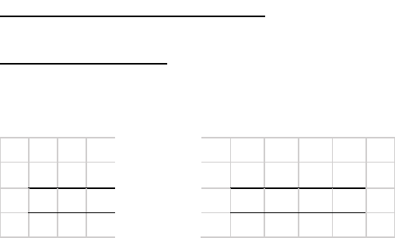
2
4
3
2
7
3
9
4
1
2
Written methods: continued
Short Multiplication:
342 x 7
x
24 x 6
 |  | 2 | 4
x |  |  | 6
 | 1 4 4
 | 2

- Recall multiplication and division facts for multiplication tables up to 12 × 12
- Use place value, known and derived facts to multiply and divide mentally, including: multiplying by 0 and 1; dividing by 1; multiplying together 3 numbers
- Recognise and use factor pairs and commutativity in mental calculations
- Multiply two-digit and three-digit numbers by a one-digit number using formal written layout
Division (short extended to with remainders): Children to continue to divide by known multiples

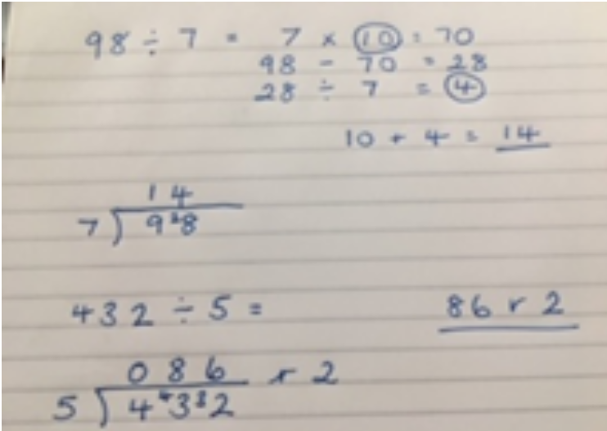

- Solve problems involving multiplying and adding, including using the distributive law to multiply two-digit numbers by 1 digit, integer scaling problems and harder correspondence problems such as n objects are connected to m objects
Mental Methods:
Children should know x 2,5,10,3,4,8 already.
They need to know:
- 6 x table
- 7 x table
- 9 x table
- 11 x table
- 12 x table
Explore what happens when we divide by 0 and 1
Factor pairs:
24 x 3
8 x 3 x 3
6 x 4 x 3

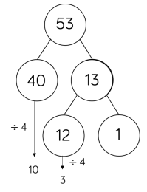
Written methods:
Part whole model/bar
model e.g.
Year 5 – Multiplication & Division
Written methods:
(Long) Multiplication:
- 2-digit x 2-digit
- 3-digit x 2-digit
- 4-digit x 2-digit
24 x 16
a) Estimate:
20 x 20 = 400
b) Calculate:
2
2 4
x 1 6

Objectives:

1 4 4 (6 x 24)

- Identify multiples and factors, including finding all factor pairs of a number, and common factors of 2 numbers
- Know and use the vocabulary of prime numbers, prime factors and composite (non-prime) numbers
- Establish whether a number up to 100 is prime and recall prime numbers up to 19
- Multiply numbers up to 4 digits by a one- or two-digit number using a formal written method, including long multiplication for two-digit numbers
- Multiply and divide numbers mentally, drawing upon known facts
- Divide numbers up to 4 digits by a one-digit number using the formal written method of short division and interpret remainders appropriately for the context
2 4 0 (10 x 24)
- Multiply and divide whole numbers and those involving decimals by 10, 100 and 1,000
3 8 4

- Recognise and use square numbers and cube numbers, and the notation for squared (²) and cubed (³)
Efficient working:
99 x 13 = (100 x13) – 13

Division:
Short Division (as year 4)
Mental Methods:

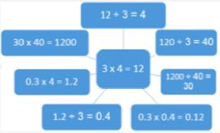
Square numbers:

1 x 1 = 1
2 x 2 = 2²
3 x 3 = 3²
4 x 4 = 4²
Cube numbers:
1x1x1 = 1³
2x2x2 = 2³
3x3x3=3³

Year 6 – Multiplication & Division

Objectives:

2
8
x
•
6
6
2 1 • 2 8
5 4

Written methods:
Confidence in all formal written methods as shown in
National Curriculum Appendix:
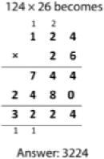
Multiplying integers by decimals
8 x 2.66 =
- Estimate: 8 x 3 = 24
- Calculate:
- Multiply multi-digit numbers up to 4 digits by a two-digit whole number using the formal written method of long multiplication
- Divide numbers up to 4 digits by a two-digit whole number using the formal written method of long division, and interpret remainders as whole number remainders, fractions, or by rounding, as appropriate for the context
- Divide numbers up to 4 digits by a two-digit number using the formal written method of short division where appropriate, interpreting remainders according to the context
- Perform mental calculations, including with mixed operations and large numbers
- Identify common factors, common multiples and prime numbers
- Use their knowledge of the order of operations to carry out calculations involving the 4 operations
c) Check:
Is your answer close to your estimate?

Short division (by one digit) see yr 4/5

Division by 2 digit numbers:
- Use estimation to check answers to calculations and determine, in the context of a problem, an appropriate degree of accuracy

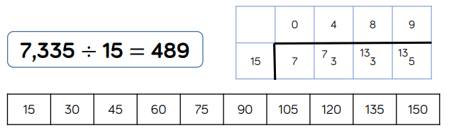

Mental Methods:
All tables up to 12 x 12 including all related
facts.
Round answers to the required degree of
Accuracy.
Order of operations using brackets e.g.
2 + 1 x 3 = 5
(2+1) x 3 = 9

