Derbyshire Catering Service
Information for Parents

Derbyshire County Council Catering Service produces approximately 50,000 meals per day across the county for the children of Derbyshire. Our Catering staff are trained in all areas of food production and service. We are proud to hold the Silver Food for Life Served Here quality award from the Soil Association.

Our current menu exceeds government guidelines and all recipes are nutritionally analysed before adding to our menu. We use high quality ingredients, sourcing local produce and are proud to work in conjunction with many local suppliers and distributors.

Research has shown that a child having regular nutritionally balanced meal achieves more academically, so we feel proud to be on that academic journey with your child.

Frequently Asked Questions

1 How much does a school meal cost?

All children of infant age (reception, year 1 and year 2) receive a free meal regardless of personal circumstances through the government’s Universal Infant Free School Meal scheme.

If you have older children and pay for meals, each school collects payment in different ways please check with your child’s school.

Some families may be eligible for a Free School Meal, we would encourage every family to complete the Free School Meal form. If you do become eligible it means school receive additional funding from the government.

2 What should I do if my child has a food allergy or intolerance?

We cater for many different types of medical diet. Please complete a medical diet request form which can be obtained from your school office. When returned, this must be accompanied by written confirmation from a health care professional. If the diet is complex, we may need to contact you to arrange a meeting to discuss your child’s requirements.

3 Do you offer faith, vegetarian or vegan diets?

Yes we do. Please speak to your individual school caterer regarding this.

4 What happens if my child is a fussy eater or has additional needs regarding food and the lunchtime experience?

Our staff are very friendly and always encourage children to try new foods where possible. You may find that by having school meals your child will try foods that they wouldn’t necessarily have at home. They will never be forced to eat a food they don’t like.

5 Does my child have to have a dinner every day or pre-order their dinner?

Derbyshire Catering Service are very flexible but each individual school has their own policy regarding this. Please check your child’s school for more information.

6 How do I get information about the food that is being served?

Derbyshire Catering Service produces two different menus each year. A menu leaflet will be sent home to you via your school. More information can be found on our website: https://www2.myschoollunch.co.uk/derbyshire/

Our aim is to provide a positive lunchtime experience that your child will remember for years to come. If you have any concerns or would like any more information, please do not hesitate to contact our friendly team.

Contact Details:

Telephone: 01629 536704
Email: catering@derbyshire.gov.uk

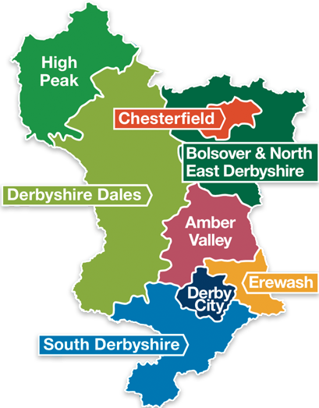 | Local Sourcing  - Bottled water from Buxton  - Potatoes from Lincolnshire  - Organic Beef from Hartington  - Grocery wholesaler based in Tideswell  - Fruit and Vegetable Wholesaler in Buxton and Matlock

